Course Recommender System in a Liberal Arts Context

Raphaël Morsomme
University College Maastricht
Zwingelput 4
6211 KH Maastricht
+32496486716
raphael.morsomme@maastrichtuniversity.nl
Sofia Vazquez Alferez
University College Maastricht
Zwingelput 4
6211 KH Maastricht
+31625246406
sofia.vazquezalferez@maastrichtuniversity.nl

ABSTRACT
Use the “ACM Reference format” for references – that is, a numbered list at the end of the article, ordered alphabetically and formatted accordingly. See examples of some typical reference types, in the new “ACM Reference format”, at the end of this document. Within this template, use the style named references for the text. Acceptable abbreviations, for journal names, can be found here: http://library.caltech.edu/reference/abbreviations/. Word may try to automatically ‘underline’ hotlinks in your references, the correct style is NO underlining.
The references are also in 9 pt., but that section (see Section 7) is ragged right. References should be published materials accessible to the public. Internal technical reports may be cited only if they are easily accessible (i.e. you can give the address to obtain the report within your citation) and may be obtained by any reader. Proprietary information may not be cited. Private communications should be acknowledged, not referenced (e.g., “[Robertson, personal communication]”).

TABLES

Table 1. Example of student data
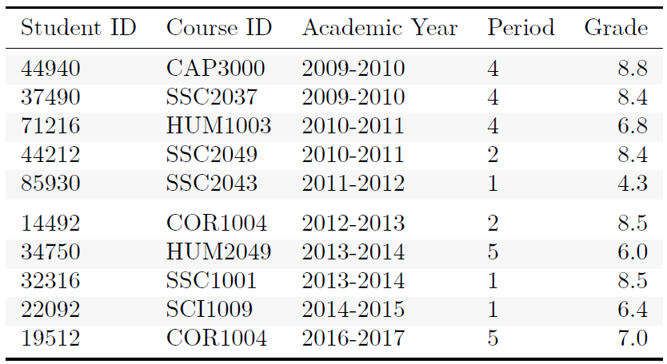

Table 2. Example of course data
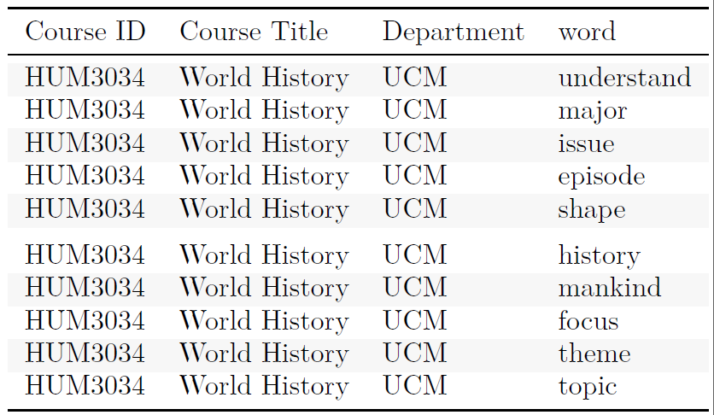

Table 3a. Toy example: topic distribution in 3 courses
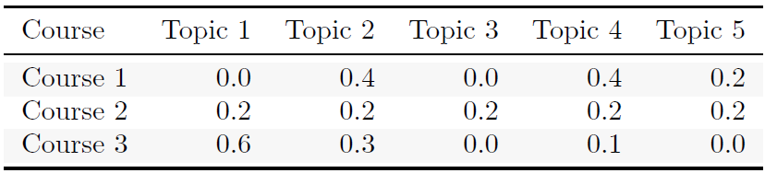
Table 3b. Toy example: transcript
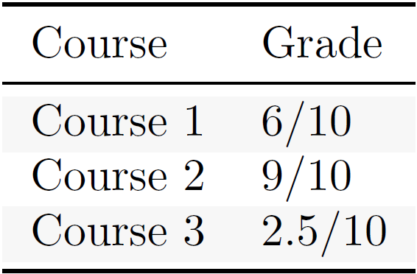
Table 3c. Toy example: course contribution to topic expertise
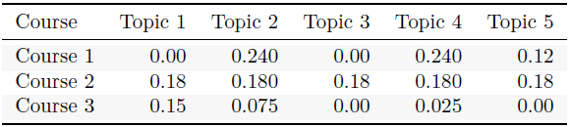

FIGURES/CAPTIONS
Place Tables/Figures/Images in text as close to the reference as possible (see Figure 1). It may extend across both columns to a maximum width of 17.78 cm (7”).
Captions should be Times New Roman 9-point bold. They should be numbered (e.g., “Table 1” or “Figure 2”), please note that the word for Table and Figure are spelled out. Figure’s captions should be centered beneath the image or picture, and Table captions should be centered above the table body.
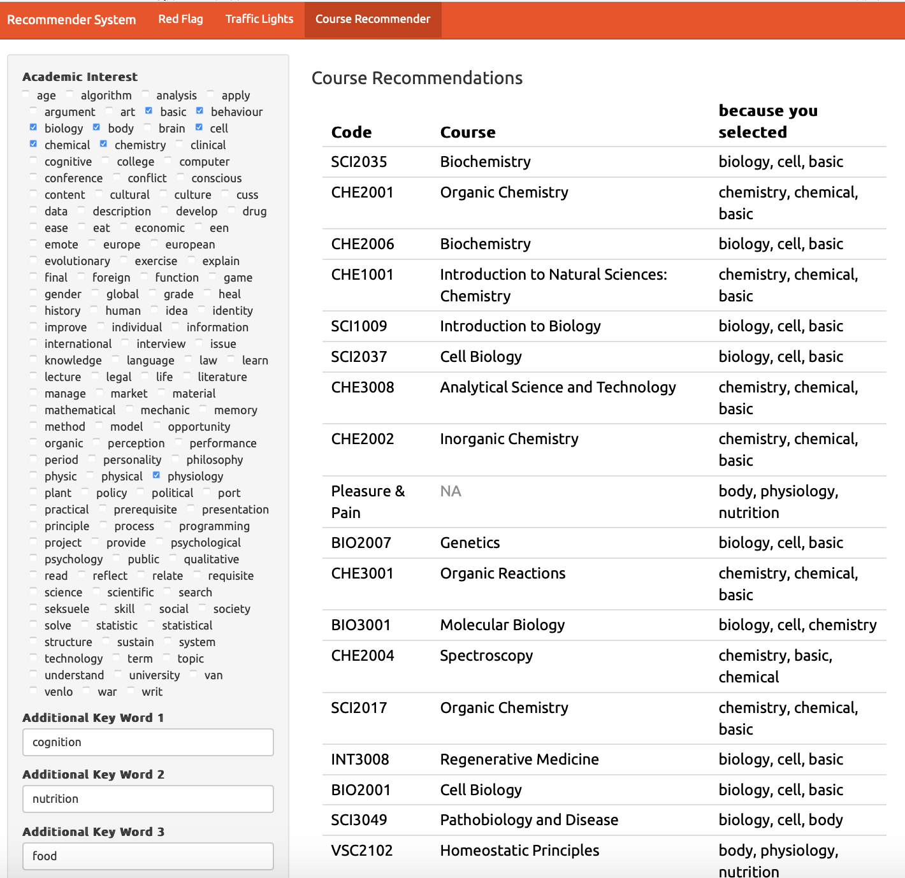
Figure X. Course suggestions in practice.

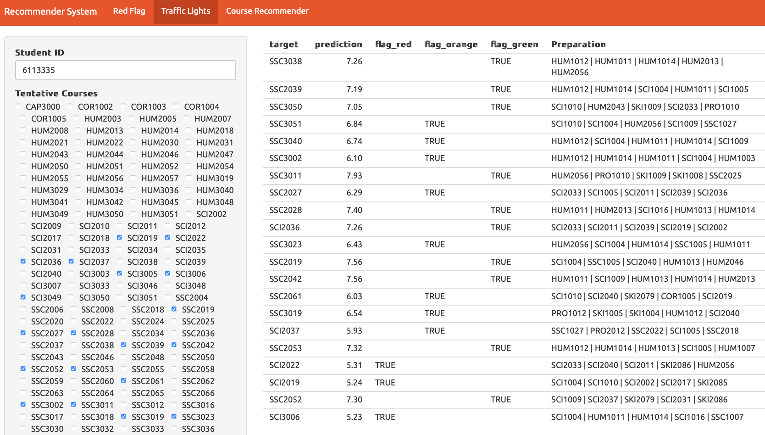
Figure X. Warnings in practice.

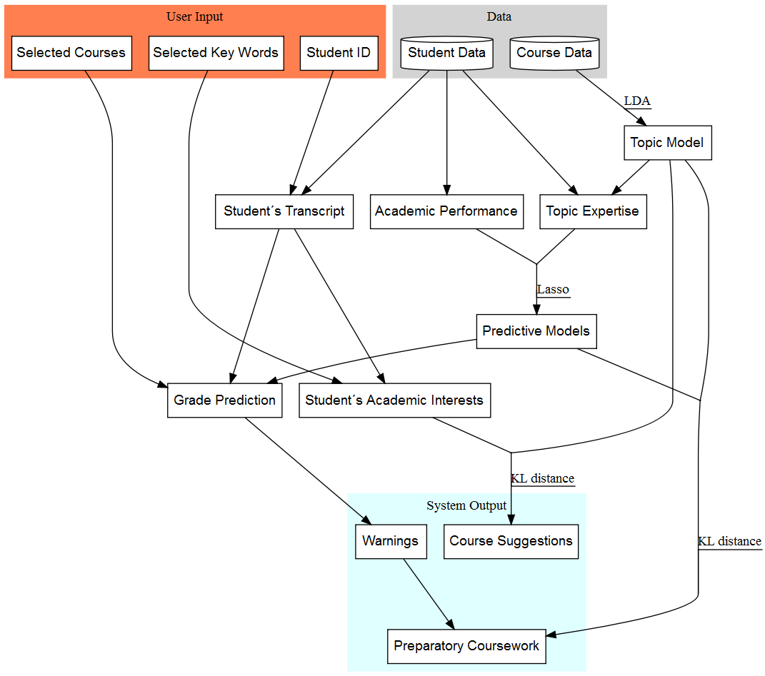
Figure X. Flowchart.

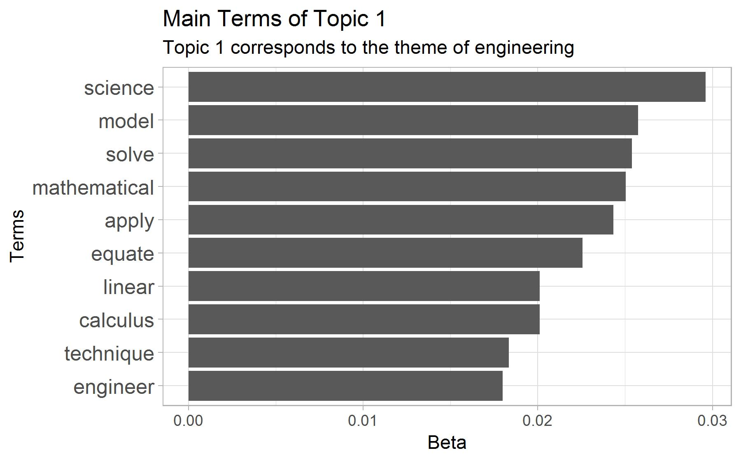
Figure X. Term distribution in a topic.

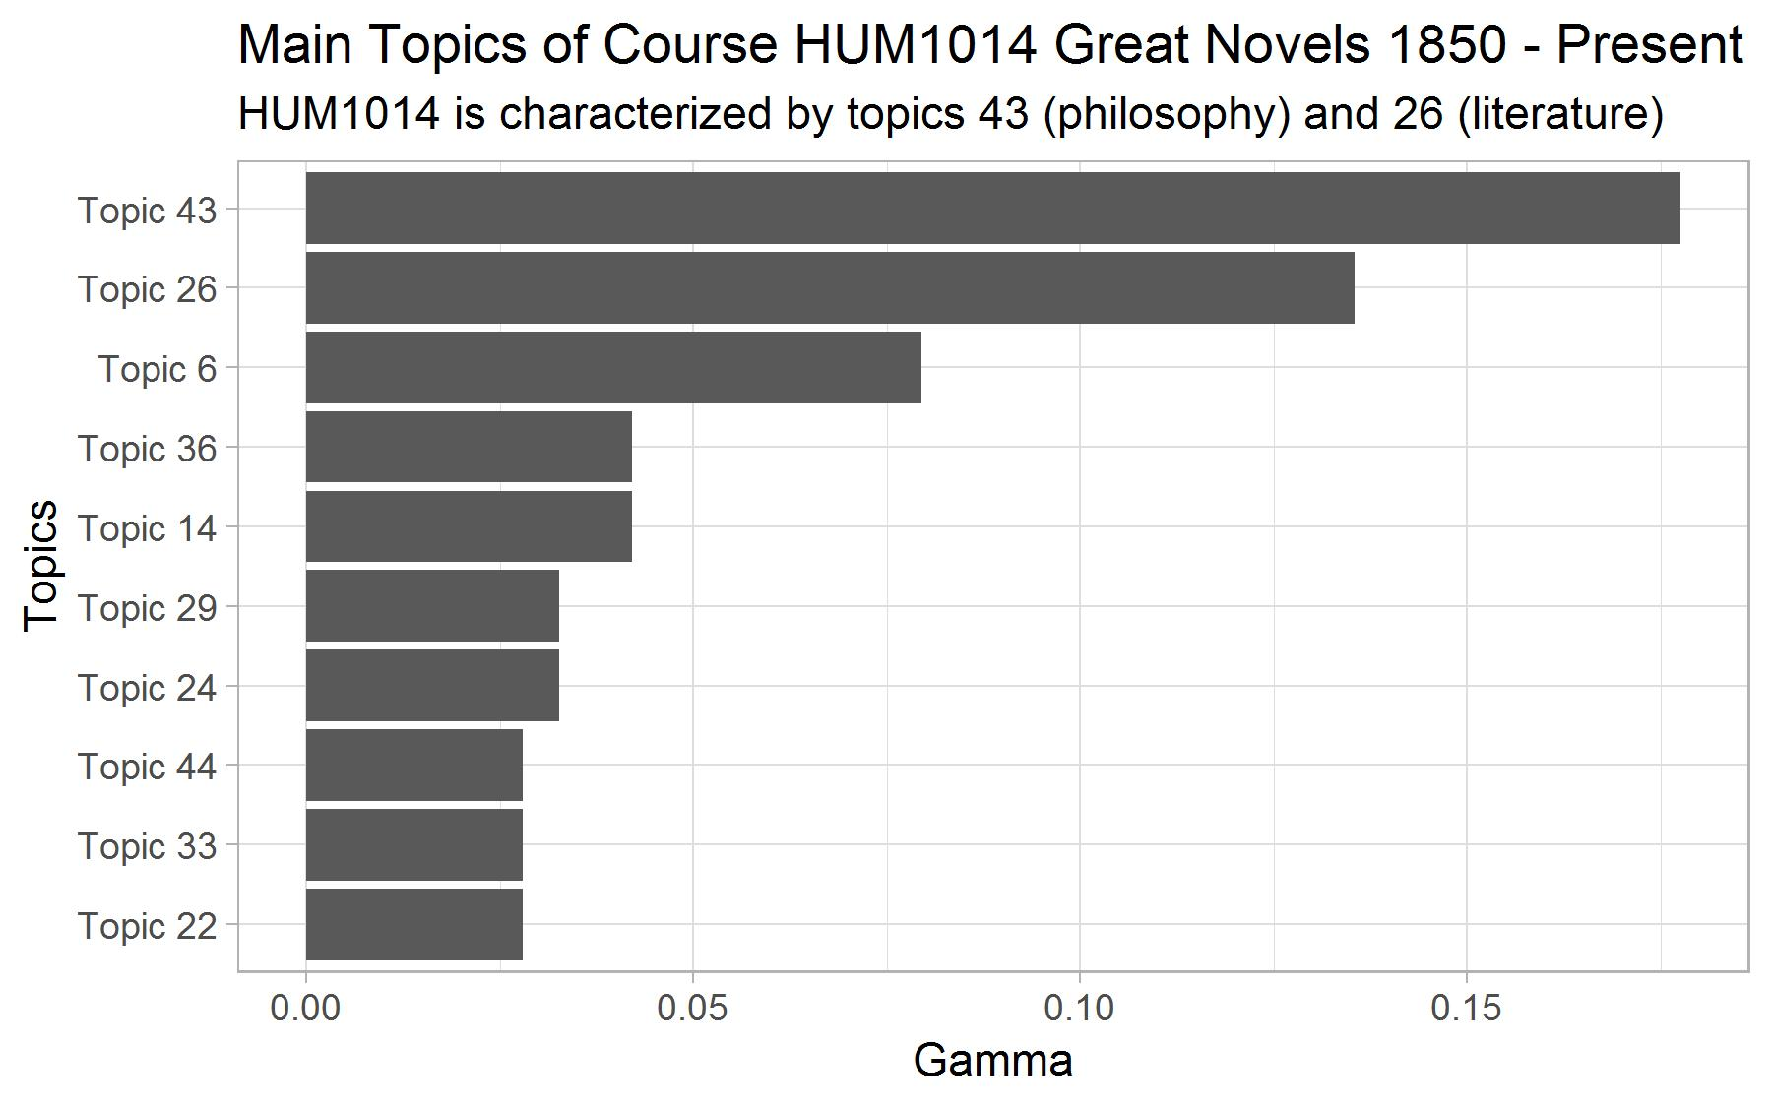
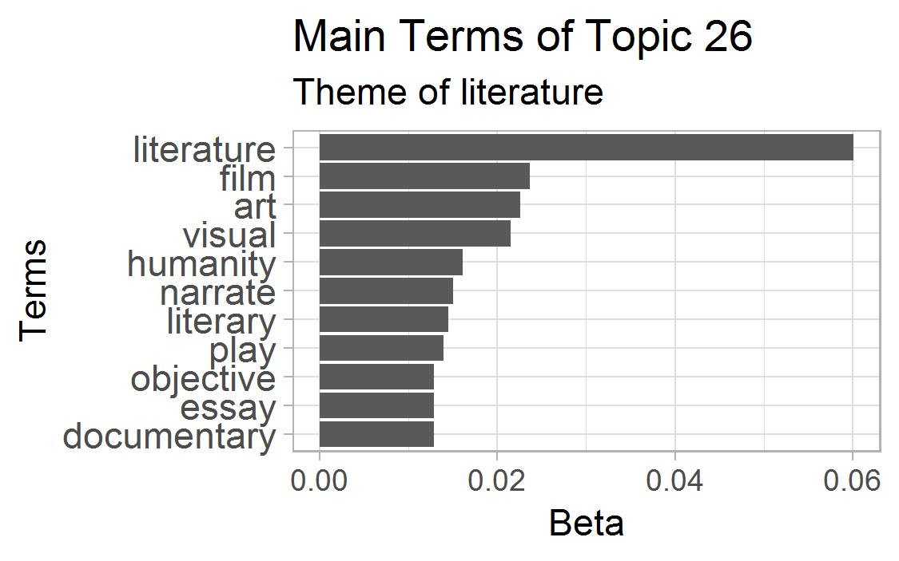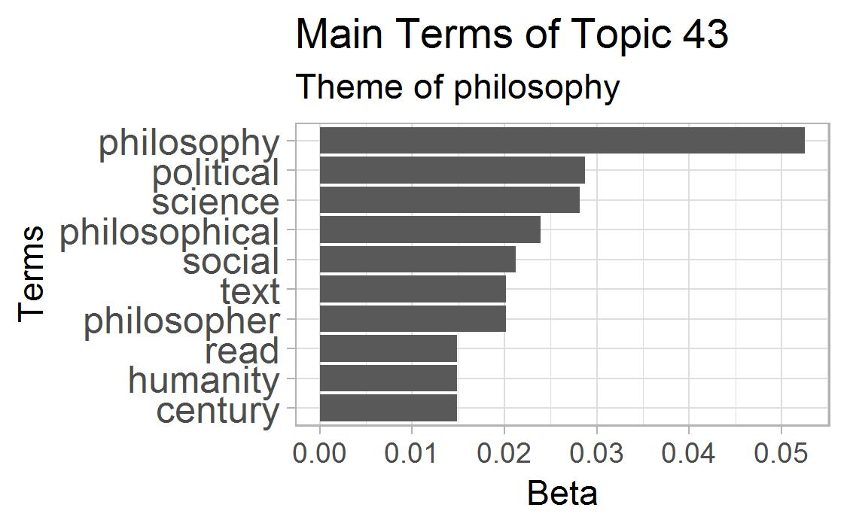
Figure X. Topic distribution in a course.

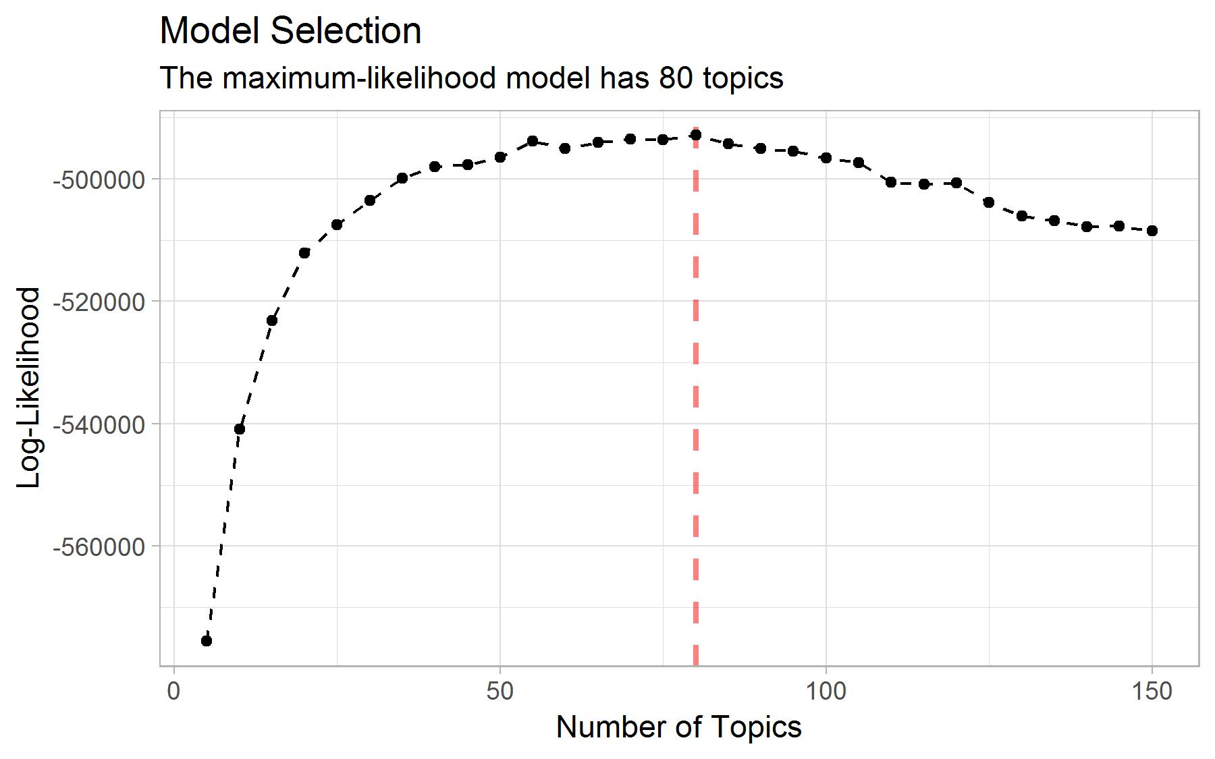
Figure X. Model Selection based on log-likelihood.

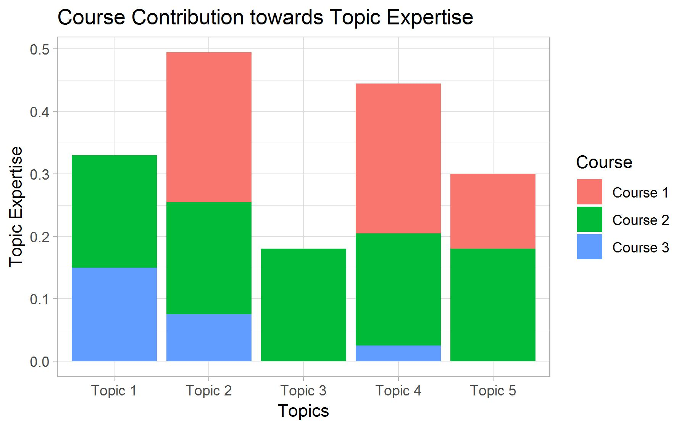
Figure X. Toy example: course contribution to a student’s topic expertise. We use these variables to predict grade.

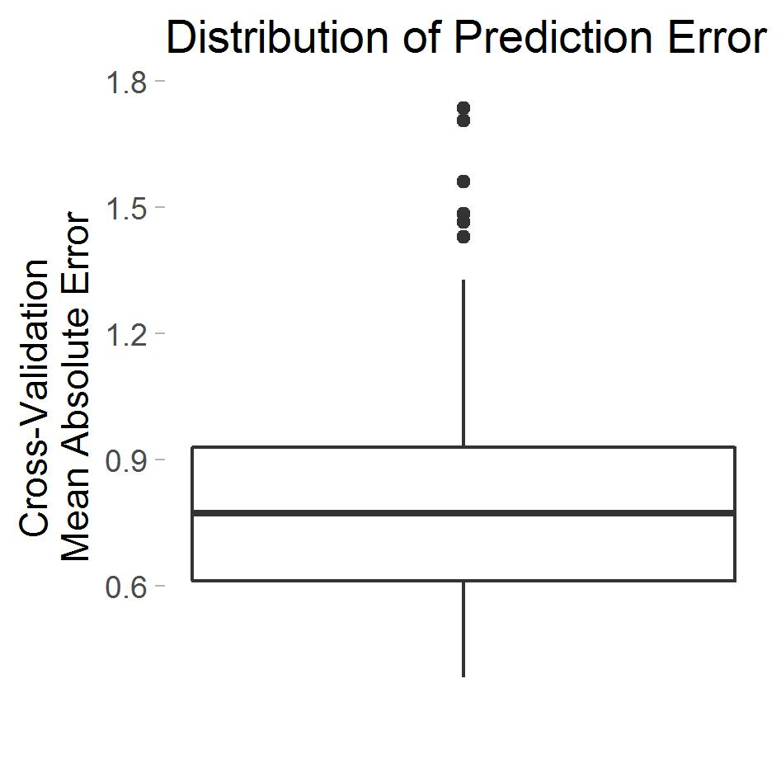
Figure X. Distribution of the cross-validation mean absolute error in the 148 predictive models.

Columns on Last Page Should Be Made As Close As Possible to Equal Length

